**Project Development Phase**

Delivery of Sprint-1

|  |  |
| --- | --- |
| Date | 17 November 2022 |
| Team members | Pavithra.L ,Priyadharshini.B,Nivedhitha.V,  Rajalakshmi.R |
| Team ID | PNT2022TMID02444 |
| Project Name | AI based discourse for Banking Industries |

Create IBM Watson Assistant Service

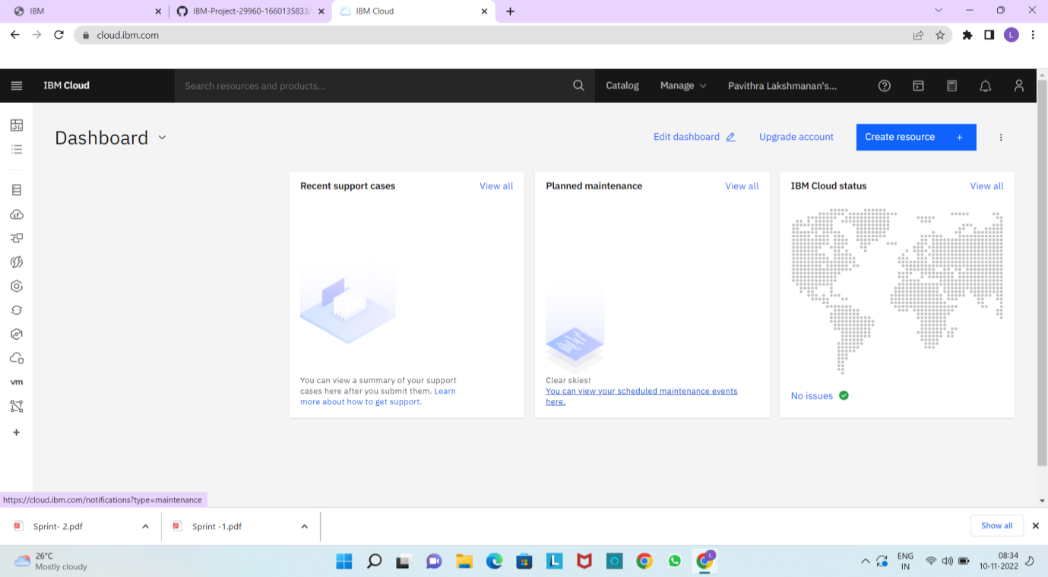

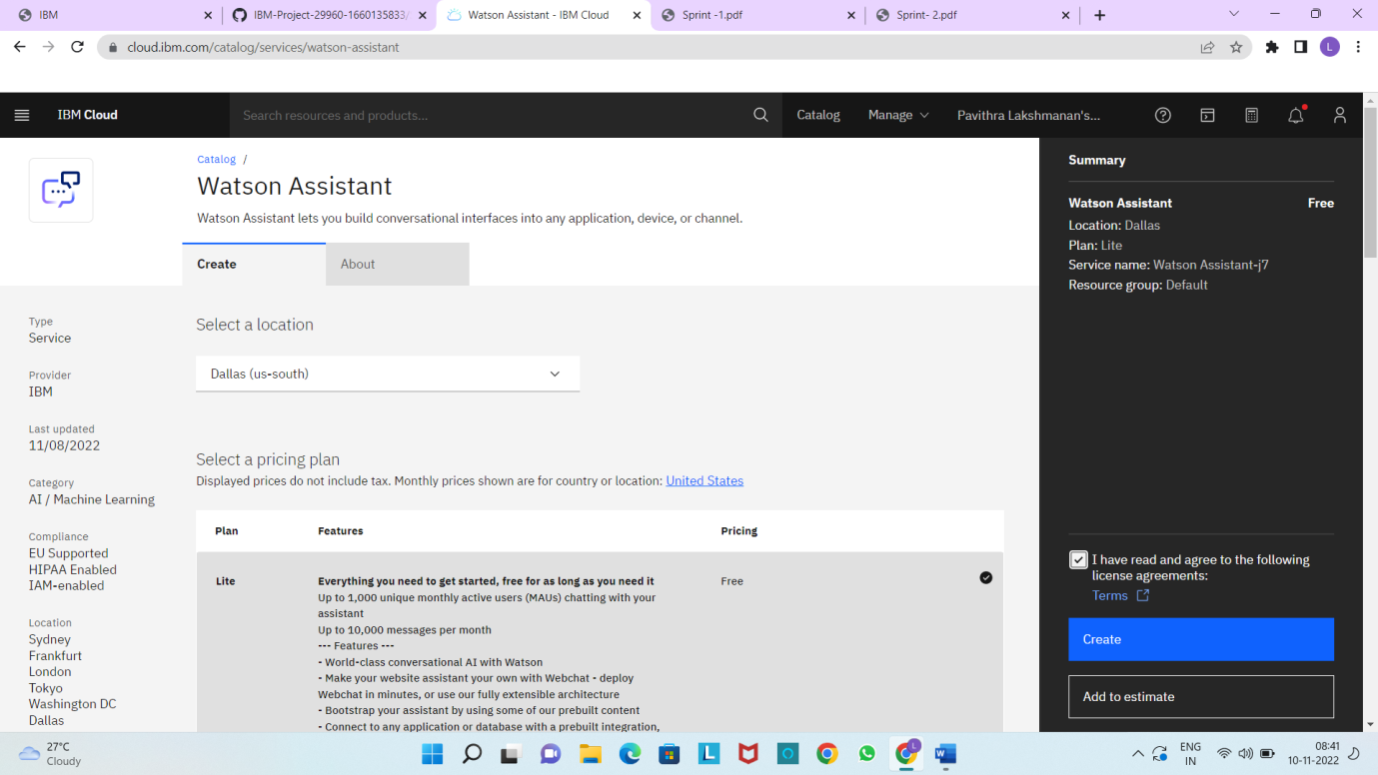

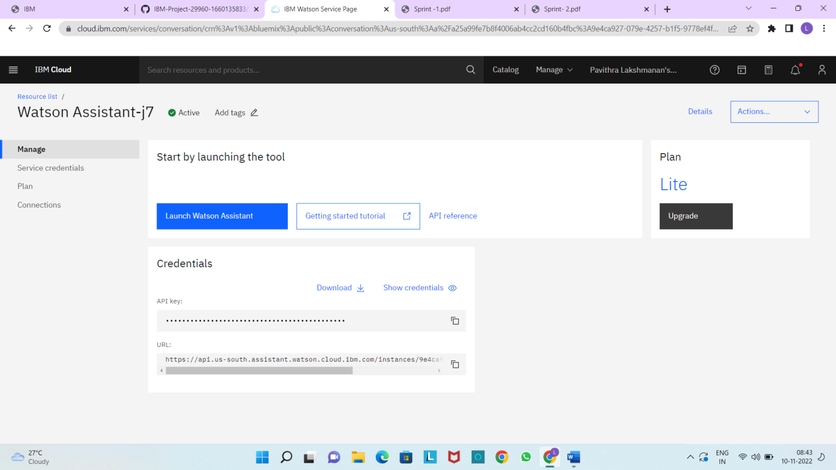

Creating chatbot action

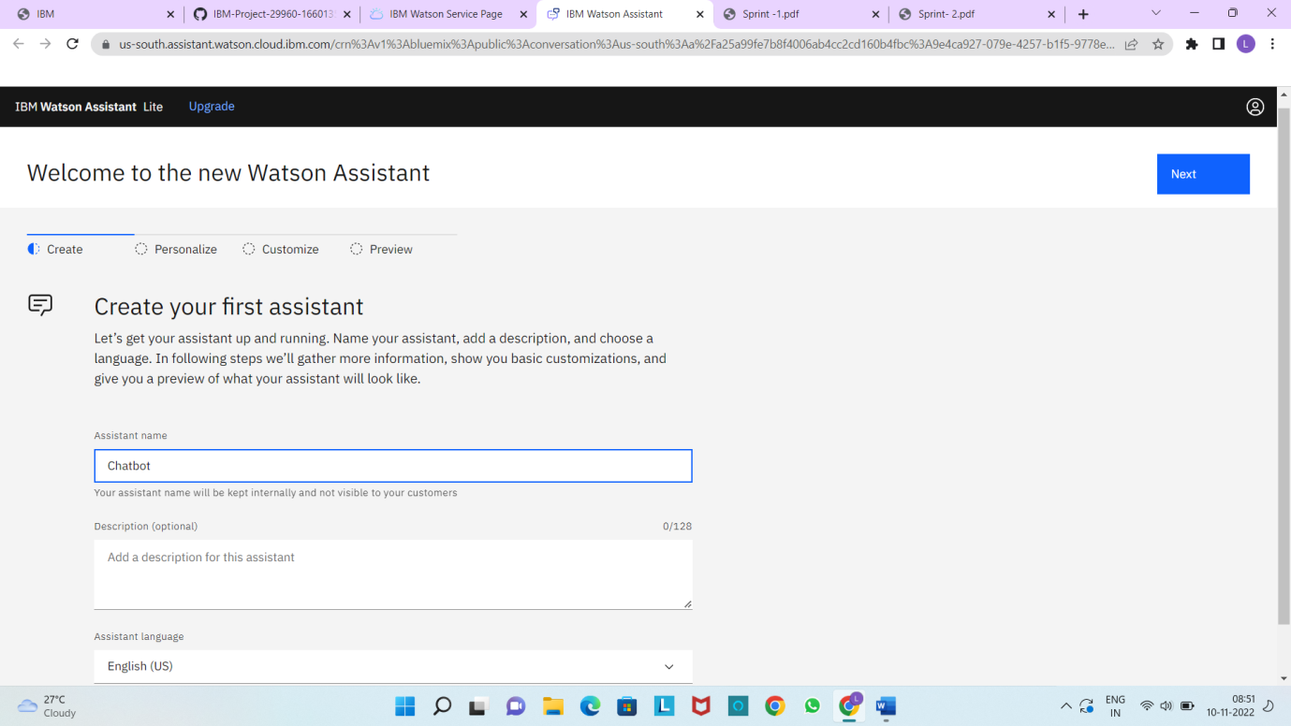

Creating the First action:

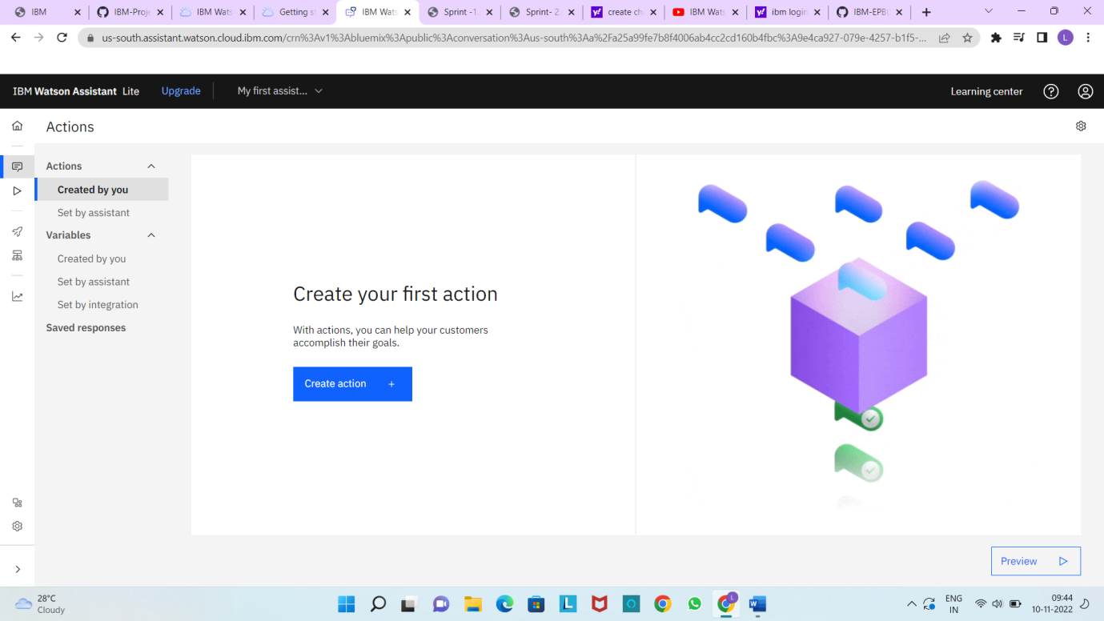

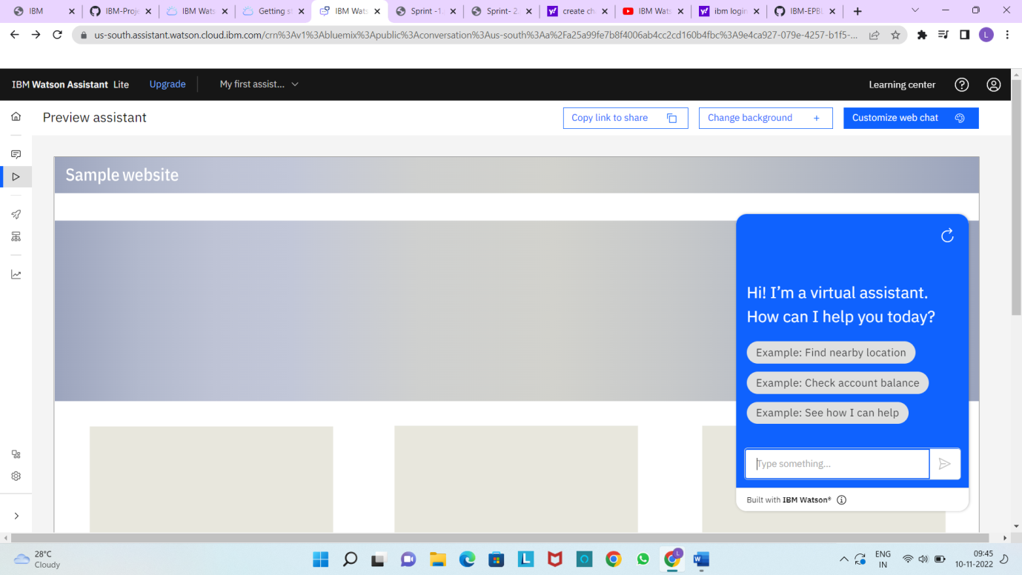

Create the Greetings action in IBM assistant:

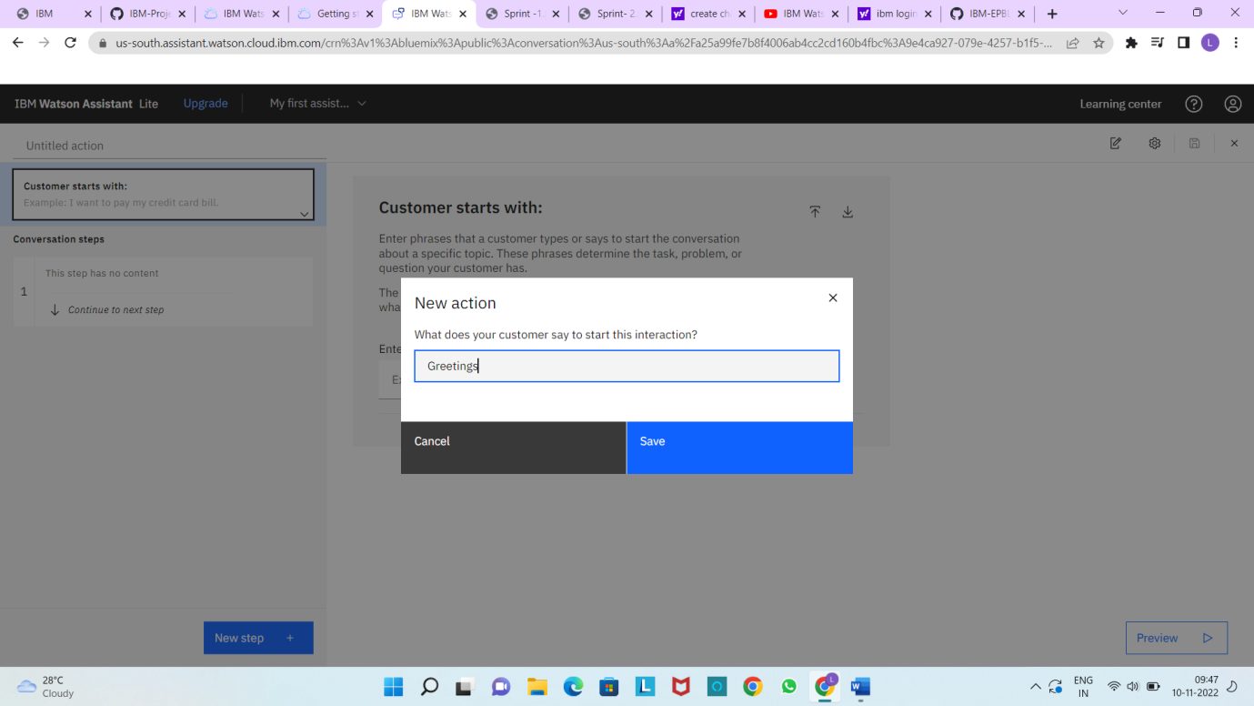

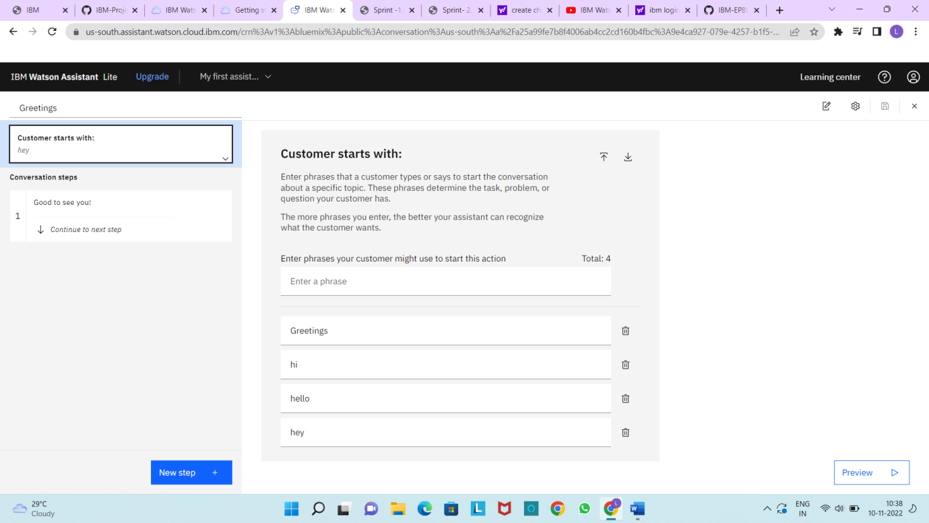

Create the Index action :

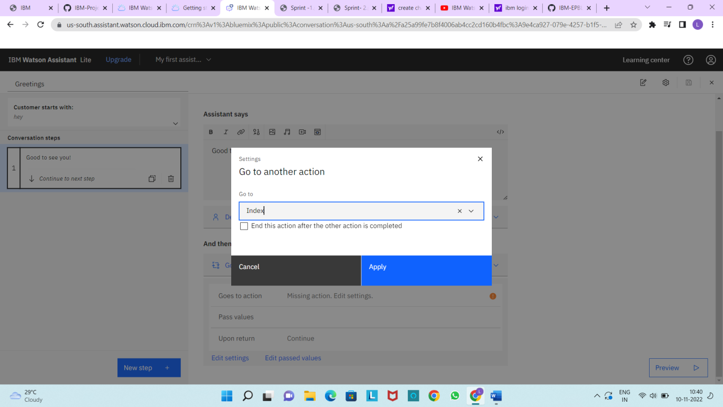

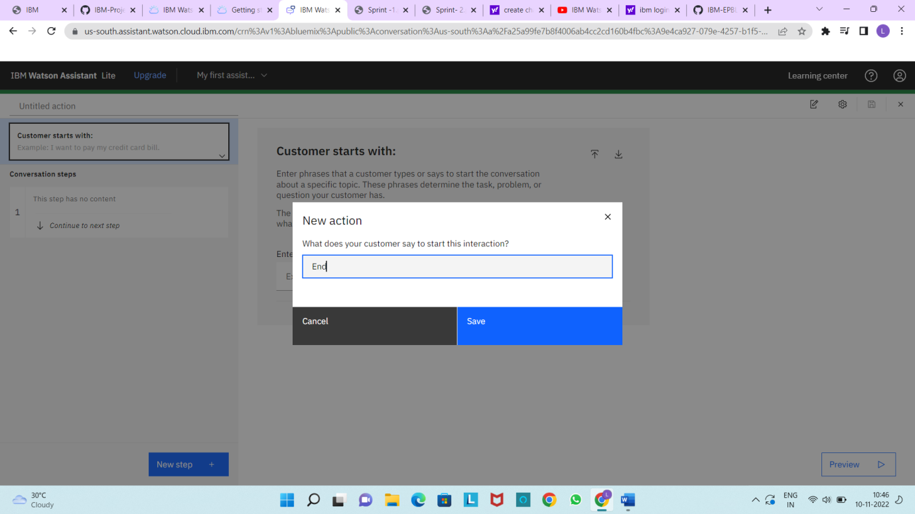

Create the Savings action:

